**Work On: A Collaborative Web-Based Application for Employee’s Work Progress**

**A Capstone Project Presented to the**

**Faculty of College of Computing and Information Technology**

**First Asia Institute of Technology and Humanities**

**Tanauan City, Batangas**

**In Partial Fulfillment**

**Of the Requirements for the Degree of**

**Bachelor of Science in Information Technology**

**By:**

**Galon, Bea Lorraine D.**

**Garcia, Angela Mae T.**

**Malabanan, Charlene G.**

**Silva, Clarence Marjorie**

**2021**

**APPROVAL SHEET**

This thesis entitled **“Work On: A Collaborative Web-Based Application for Employee’s Work Progress”** prepared and submitted by **Bea Lorraine Galon, Angela Mae Garcia, Charlene Malabanan and Clarence Marjorie Silva** in partial fulfilment of the requirements for the degree of **BACHELOR OF SCIENCE IN INFORMATION TECHNOLOGY** has been examined and is recommended for Oral Examination.

**Dr. MARICEL MALABANAN- GASPAR, DIT**

Co-adviser

**ACKNOWLEDGEMENT**

Milestones are dependent on the support and motivation of others in addition to the researcher's contributions. The researchers will be unable to complete the study's objectives without them. The researchers would like to express their heartfelt gratitude to the individuals listed below for their invaluable assistance and encouragement.

To Almighty God, for giving us the courage, knowledge, encouragement, and direction we needed to achieve our goals; for the guidance that enabled me to overcome all obstacles and difficulties encountered; and for providing the motivation we needed to complete this study.

To the researchers' parents, for their help and assistance in pursuing his study, as well as for their unending love, which keeps the researchers excited and determined to complete the study.

Dr. Maricel Malabanan-Gaspar and Dr. Raymund Baesa, who unwaveringly shared their experiences and devoted their entire effort to assisting the researchers during the system's development.

Finally, many thanks to everyone who helped and provided excellent ideas and advice; without them, this research would not have been possible

**TABLE OF CONTENTS**

**PAGE**

**TITLE PAGE i**

**APPROVAL SHEET ii**

**ACKNOWLEDGEMENT iii**

**TABLE OF CONTENTS iv**

**LIST OF FIGURES AND DIAGRAMS v**

**CHAPTER**

1. **BACKGROUND OF THE STUDY** 1

Introduction 1

Objectives of the Study 3

Scope, Limitation, and Delimitations of the Study 4

Significance of the Study 5

1. **REVIEW OF LITERATURE** 6

Conceptual Literature 6

Related Literature 7

Related Systems 9

Synthesis 10

Conceptual Framework 11

Conceptual Paradigm 12

Definition of Terms 13

1. **RESEARCH METHODOLOGY** 15

Research Design 15

Scrum Methodology in Agile Method 18

System Requirements 19

Statistical Treatment of Data 20

Evaluation Questionnaire 21

Subject of the Study 23

Data Gathering Instrument 23

Data Gathering Procedure 24

UML Diagrams 24

Use Case Diagrams 25

Data Flow Diagrams 28

Database Schema 29

References 29

**LIST OF FIGURES AND DIAGRAMS**

**FIGURE PAGE**

**CONCEPTUAL FRAMEWORK 11**

**AGILE METHODOLOGY 16**

**SCRUM METHODOLOGY 18**

**USE CASE DIAGRAM FOR ADMINISTRATOR 25**

**USE CASE DIAGRAM FOR USER 26**

**USE CASE DIAGRAM FOR PROJECT MANAGER 27**

**DFD LEVEL 0 DIAGRAM 28**

**DFD LEVEL 1 DIAGRAM 29**

**DATABASE SCHEMA 30**

**CHAPTER I**

**BACKGROUND OF THE STUDY**

**Introduction**

Remote working is one of the in-demand methods of working nowadays because of pandemic, and limited access of face-to-face offices and meetings. By this remote working, it is hard to track and monitor the task progress of the employee. Virtual meetings, email, chats and text are one of the easy ways to give an update regarding the work progress of an employee.

Remote working is possible for everyone because of the connection between three parties, the administrator, the project manager and user through internet and with the help of tool used on accessing tasks and projects. This allows users to simply interact to the task and projects given by the administrator or project manager. And because of the Work-On web based application, it is easy for users to easily monitor and track tasks and projects. Since the remote working are done using computers or any gadgets that can run using remote access applications that was also based on an existing technology, this paper only reveals on how our Work-On web based application will work and keeps organized dissemination of task and projects. This study further present how will Work-On web based application will be effective and reliable tool will.

Users, especially professionals often need help outside from traditional office when face to face communication is not possible especially this time of pandemic. It applies to our study to create and utilize a web based application for administrator, project manager and users when it comes to tracking, monitoring and disseminating of tasks and projects. The opportunity to create an application that will ease difficulties on doing tasks and projects in an online circumstance is an extent on which users are willing to use this proposed tool for monitoring and tracking task progresses. The potential use of this tool is to demonstrate how will give tasks and projects will be disseminated and track productivity of the users.

Send of work progress in chats and emails are one of the easy way to submit and update employee’s task however, this will be better if management of work enables the employees to track their work progress in a proper manner because sending a progress and updates of work in emails and chats may lead to unread messages and spam. This may lead to incomplete group work output, miscommunication and work problem.

Use of monitoring and tracking software is a solution for the work problem that may encounter when having a group work, like miscommunication, difficulty handling the employee’s task progress, employee’s lack of productivity, hard to identify the work problem. Tracking of work when done simultaneously reduce the failures of task. Use of tracking and monitoring of task increase the productivity of the employee because it improves employee ability to estimate the time of completion of tasks and projects. Use of track and monitoring software for the employee may be a basis of their evaluation and time-spent. Done task are secured and prevent internal theft in having a tracking and monitoring software.

The Work On is a software tool that track and monitor employee’s task progress by the project manager and admin. This software has data sync for the submitted files, notes for the important announcement, given date started of each task and project, due date, and status update of task that can view, edit and delete.

These features will help the project manager to monitor their members accomplishing their given task. Tracking and monitoring progress makes members to have an efficient decision regarding to delegating a task and using resources.

This Work On is used by project managers and admin as they are the one who provide and assigning a task for their team members and employees, and this is also for the project members that will cooperate to their group project work to accomplish all their given task and reach their goal. The client for our Work On Web-Based Application is the College of Computing and Information Technology (CCIT) faculty.

In order to provide this software tool, the researchers used PHP: Hypertext Preprocessor, a widely-used open source general-purpose scripting language that is especially suited for web development and can be embedded into Hyper Text Markup Language (HTML) together with Structured Query Language (SQL), a standard markup language for documents designed to be displayed in a web browser that assisted by a scripting language---JavaScript. SQL is for the database updating and storing. We used Bootstrap for the design of our web-based application with a small addition of JavaScript and Ajax. For the IDE, we used Visual Studio Code (VSCode), an integrated development environment made by Microsoft for Windows, Linux and macOS.

**Objectives of the Study**

**General Objectives:**

The General Objectives of this study is to create a Web-Based Application that can track and monitor employee’s work progress.

**Specific Objectives:**

Specifically, the project aims the following:

1. To create and develop a system that capable of

1.1 Providing a task where the Project Manager or Admin can assign and give a task to their project members or employees.

1.2 Providing a task where the Project Manager or Admin monitor their Project Members working on their given task.

1.3 Providing a task and project that can update and edit the project task in real time.

2. To provide a system that capable of

2.1 Having data sync for the submitted files, and notes for the important announcement.

2.2 Having security through confirmation of strong password.

3. To provide a module where the system can generate report based on:

3.1 Task progress of the Faculty and Chair, on which it has a

3.1.1 Main Task Name

3.1.2 Assigned Task

3.1.3 Completed Task

3.1.4 Work Duration

3.1.5 Progress Percentage

3.1.6 Status

**Scope of Limitation and Definition of the Study**

The capstone project namely Work-On involves development of an application that includes different function features that will be available in web-based application format on which, this will help the CCIT faculty to monitor and track the progress of their ongoing tasks. It serves as a tool to easily monitoring finished, ongoing and unfinished tasks of the faculty. In the web-based application, the feature format of the Work-On application will be available online and will publish on at least one web server. One main feature of this application is, it has a data sync for the submitted files, notes for important reminders and announcements, given start of date and due dates, viewing of status update of tasks, and viewing of progress analytics. This capstone project will be presented to CCIT faculty of First Asia Institute of Technology and Humanities. Delimitation of our capstone project aims to narrow the scope of our project. This, limit the scope and describe the boundaries of our project. The delimitation of our capstone project is the Internet connectivity. The project is required to have an access to the Internet in order to use the application and for syncing of data. This project is limited only to CCIT Faculty of First Asia Institute of Technology and Humanities (FAITH) which conclude that beyond the department premises is not accounted for, because this project is only stationed within CCIT faculty.

**Significance of the Study**

The researchers aim to develop an application entitled "Work On - A tracking and monitoring of employee’s work progress" that will allow the leader to track and monitor their employees' task progress.

The researchers assumed that the study would become significant to the following:

**College Dean.** This study allows the dean to track and monitor the task progress of the faculty to ensure that everything runs smoothly.

**Program Chair.** The program chair subordinate of the organization that allows to undertake the track and monitoring duties of the faculty if the college dean is unavailable.

**Faculty.** This study will allow the faculty to increase their productivity because they have the ability to estimate the time of completion of tasks and projects. They are also able to look back at their workloads and optimize productivity. In addition, this study may also be a basis for the faculty in their evaluation and time spent.

**Researchers.** The proposed research would benefit the researchers by learning on how to spend their time in being productive and to complete more tasks.

**Future Researchers.** The study will be used as a guide for future similar studies by future researchers. They can utilize concepts and ideas.

**CHAPTER II**

**REVIEW OF RELATED LITERATURE**

This chapter discusses conceptual literature, related literature, and the conceptual framework. To fully understand the current issue, extensive research into various resources is required to demonstrate the dependability of the current system. In this section, we will look at the problem statement and its justifications.

# Conceptual Literature

The sequential literatures and related articles were gathered to provide additional information about the systems used in the project's development. This study incorporates the following ideas and concepts from background of the study.

According to Time Doctor (2021), Employee monitoring or employee tracking refers to the techniques an employer uses to monitor employees during working hours. This includes tracking an employee’s computer activity, email and network usage, time spent on tasks, location, and more.

Electronic Performance Monitoring (EPM) refers to the now-common use of technological means to observe, record, and analyze information that directly or indirectly relates to employee job performance (Bhave, 2014; Stanton, 2000).

Advances in information technologies, the reduction of costs of those technologies, and a paradigm shift of work into cyberspace have created an environment in which organizations are able to monitor employees to a greater extent, and with greater intensity, than was previously possible (Holland, Cooper, & Hecker, 2015).

Many forms of EPM (e.g., video monitoring, call monitoring, electronic medication administration records, GPS tracking, wearable electronic safety monitors, electronic time clock systems, e-mail and Internet usage monitoring) are already widely used, and technologies such as microchip wrist implants (e.g., Astor, 2017) and body heat sensor desk hardware (e.g., Morris, Griffin, & Gower, 2017) may be the future of work monitoring.

The world has changed dramatically in the 20 years since the last comprehensive review of EPM research was published (Stanton, 2000). For example, portable devices, such as smartphones, capable of collecting large amounts of personal and behavioral data about employees, are ubiquitous today but did not exist in 2000. This rapidly changing environment of information technologies, and the growing prevalence of EPM, make a theory-based and detailed understanding of the effects of EPM critical. Thus, the time is ripe to review and integrate the past two decades’ worth of EPM research, examine big questions in EPM that have developed over the past 20 years, and identify gaps in our knowledge, with the goal of advancing both theory and practice in this area.

Studies comparing EPM to traditional monitoring have found that EPM and traditional monitoring differ in their effects on employee work patterns (Griffith, 1993) and employee compliance (Boyce, 2017) and in the degree to which monitoring results in social facilitation effects (Aiello & Svec, 1993; Laird, Bailey, & Hester, 2018).

# Review of Related Literature

Nowadays, remote working is in demand because of pandemic that leads to lockdown of offices and other work places. Most people are now in remote working or work from home set-ups. Employers and team leaders are having a hard time to monitor their employees and team members because of the remote set-up. The studies related to this topic are given below for further improvement of the project study.

Kalischko and Riedl (2021) states that the rise of digital and interconnected technology within the workplace, including programs that facilitate monitoring and surveillance of employees is unstoppable. The COVID-19-induced lockdowns and the resulting increase in home office adoption even increased this trend. And according to Madhikar (2021), most employees in the company engage in activities outside of their office duties that are unknown to the office manager. In this case, the “Employee Tracking and Monitoring System for Android” gives managers a tool to track and monitor their employees' official cell phone activities outside of work.

One of the solution provided for the hard-worker employers is to use a task monitoring and tracking software that can be used both in laptop computer, desktop and mobile phones to maintain the communication of the employers to their employees for their given task and to monitor and track of their work progress.

According to Nagel and Schwade (2020), the growth of Enterprise Collaboration Systems (ECS) and the emergence of Social Media have reignited interest in how individuals engage in the digital workplace utilizing computer mediated technologies. Employees expect to use socially enabled tools in the workplace as their personal use of social media grows. As a result, businesses implement ECS to facilitate staff collaboration and communication. And Kehinde & Okafor (2019) stated that every organization requires some type of monitoring and supervision to guide and direct the behavior of its members and improve their performance in the organization's activities. In corporate organizations, electronic monitoring is a continual and significant component. Electronic monitoring has taken many forms over the years, including direct supervision of work by superiors, files and record keeping about employees' work lives, the use of timetables and task schedules, and more recently in the use of information and computer technologies to monitor work performance in modern organizations.

With the rapid growth of communication and information technologies are speeding up corporate processes and enhancing cooperation, collaboration tools, and information systems are beginning to garner greater attention in business life. Communication, synchronization, and information sharing are all issues that many separated teams working on the same project face, especially in today's globalized international economy (Cilgin and Tecim, 2018). Therefore, communication through technologies have an impact to improve the organization and company in their business life. In the study of Cilgin and Tecim (2018), web-based collaborative tools go beyond organization and traditional collaborative approaches, allowing people from all over the world to work together in real time. Various information technologies and collaboration tools utilized at universities, within the same scope, make business activities feasible and facilitated. It is easier for students, academics, and administrative personnel to monitor, plan, and control procedures using these numerous information systems and collaborative technologies.

Andersson and Mutlu (2020) emphasized that today's technical advancements, along with greater corporate demand, are resulting in workplaces that are increasingly reliant on digital collaboration solutions. It transforms the digital landscape for businesses and their executives.

**Related Systems**

Researchers conducted the gathering of related systems to contrast the proposed project system. The table below shows the comparison of the features of the existing collaborative applications and our proposed system, Work-On. The features that the Monitask, a monitoring software tool does not have a features of uploading of files and can have a multiple group in their interface. The HiveDesk is the same with Monitask. In Proof Hub, the features that they don’t have are the uploading of files, and timesheet since they only used a calendar for their schedules and deadlines. The Redbooth is the same features with the Monitask, HiveDesk. The rest of the existing application don’t have a daily report of the user in their software collaborative tool. Overall, the features that we have are the assigning of task, uploading of files, tracking of task, creating project, multiple groups, timesheet, and daily report.

# 

# Synthesis

The primary goal of each employee tracking and monitoring system is to develop a system that will assist the employer or team leader in tracking and monitoring employee task progress. Furthermore, it was discovered that each system has its own set of target respondents. The system is designed to meet the respondents' needs and abilities.

The rise of remote work brought on by the Corona Virus (COVID-19) pandemic has spurred faster adoption of employee monitoring software by companies who want to boost productivity — and keep an eye on their employees. The COVID-19- induced lockdowns and the resulting increase in home office adoption even increased this trend. One of the most important tasks for managers and leaders is to track and monitor their employees' work progress. Using Traditional methods of monitoring and tracking of employee work progress can be time-consuming and inefficient. The requirement for an employee tracking information system is to assist in the management, monitoring, searching, tracking, and updating of employee records becomes critical. Companies are finding it tough to keep a tight grip on employees while working from home. Using a Tracking and monitoring of employees work progress software is extremely useful for managers who want to monitor their employees through mobile phones and also on web. These technologies offer a wide range of capabilities that can provide employers with unprecedented insight into how their employees spend their time at work, including the websites they visit, the apps they use, and, in some cases, the ability to record their keystrokes and desktop sessions.

The researchers found out that using of monitoring and tracking software is a solution for the work problem that may encounter when having a group work, like difficulty handling the employee’s task progress, employee’s lack of productivity, hard to identify the work problem.

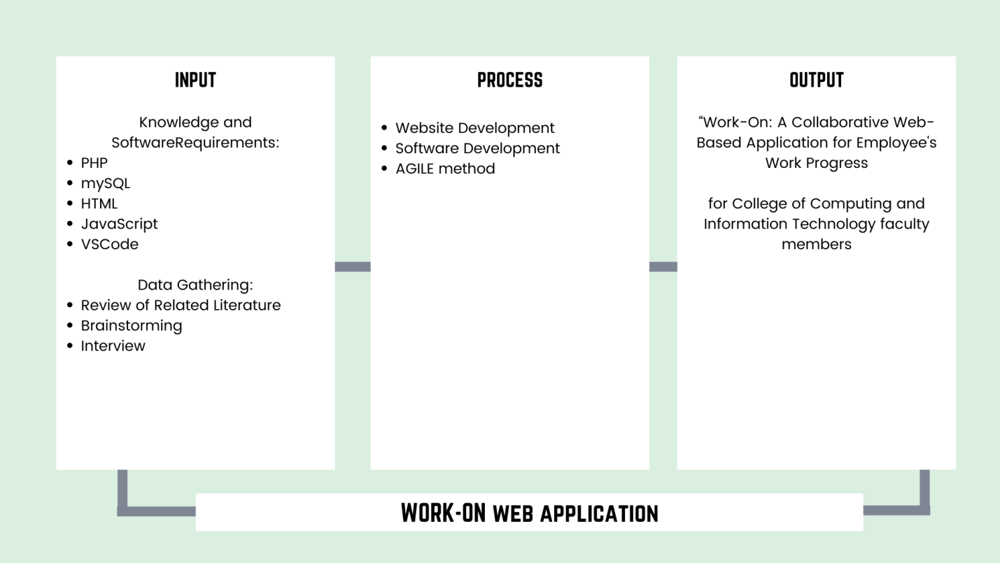**Conceptual Framework**

**Figure 1. Conceptual Framework**

The conceptual framework of this project show on figure 1 aims to analyze and get a thorough understanding of the occurrence of the capstone project, the Work-On Web Based Application. The visual representation of will show through input, process and output of the capstone project. The following variables embodies the direction on which the project will have tackle, the research paradigm or conceptual framework.

The Input-Process-Output model is a functional graph that identifies the inputs outputs and required processing tasks required to transform inputs into outputs. The inputs represent the flow of data and materials into the process from the outside. From knowledge and software requirements that the researcher’s used, PHP, SQL, HTML, JavaScript and VSCode as platforms then, data gathering from accumulating review of related literature that gives the researcher the ideas in brainstorming phase and the final interview for some validations of the researcher’s project. The process part of this model which includes tasks required to effect transformation of the inputs from website development to software development and with the use of AGILE method. Lastly, the output part of this model are the data and materials flowing out of the transformation process which the researcher’s naming it as the “Work On” web based application.

**Conceptual Paradigm**

The paradigm represents the conceptual framework of this capstone project. The Input-Process-Output (IPO) model, a functional graph that identifies the input, process tasks required to alter input into output was created and developed by Harris and Taylor on 1997 and was used to serve as guide in the general direction of this project.

The input requirements consist the knowledge and software requirements used to develop the application. This represents the data flow, materials used to process, planning stage, gathering of data from other related existing application and getting validation to future users. The process requirements include all the necessary tasks and development required to take effect the transfigure of the initial input of the project from web-based application development, software development and AGILE method. For the output requirements, this is the overall, finished project from initial planning phase to transformation of this project application.

# Definition of Terms

This study aims to thoroughly understand the definite key concepts and constructs in this capstone project. This will briefly have introduced in this chapter phase to allow the reader to comprehend and make sense of what is being presented in the following subsequent chapters of this paper.

**Remote working** means working from anywhere other than the office, which can be your home, cafe, or just a co-working space.

**Tracking** is used for the observing of persons or objects on the move and supplying a timely ordered sequence of location data for further processing.

**Monitoring** means to observe and check the progress or quality of something over a period of time or keeping under systematic review.

**Web-Based Application** is any program that is accessed over a network connection using HTTP, rather than existing within a device’s memory and this typically often run inside a web browser.

**PHP (Hypertext Preprocessor)** is an HTM embedded web scripting language that can be inserted into the HTML of a web page. It is widely used open source general purpose scripting language that is specifically suited for web development.

**HTML** (Hypertext Markup Language) is a standardized system for tagging text files to achieve font, color, graphic, and hyperlink effects on World Wide Web pages.

**SQL (Structured Query Language)** is a standard markup language for documents designed to be displayed in a web browser. It is widely used for accessing and manipulating databases.

**VSCode (Visual Studio Code)** is a code editor redefined and optimized for building and debugging modern web and cloud applications.

**IDE (Integrated development environment)** is a software for building applications that combines common developer tools into a single graphical user interface (GUI).

**GUI (Graphic User Interface)** is a form of user interface that allows users to interact with electronic devices through graphical icons and audio indicator such as primary notation, instead of text-based user interfaces, typed command labels or text navigation.

**Bootstrap** is a free and open source front end development framework for the creation of websites and web apps.

**JavaScript** is a text-based programming language used both on the client-side and server-side that allows you to make web pages interactive.

**AJAX (Asynchronous JavaScript And XML)** is gradually being replaced by functions within JavaScript frameworks and the official Fetch API Standard.

**CHAPTER III**

**RESEARCH METHODOLOGY**

This chapter cope up with methods, procedures, and instruments that are gathered correctly by the researchers for the study. The techniques used by the researcher are given here.

**Research Design**

The descriptive research method was used in this study. A descriptive research design helps provide answers to who, what, why, where, and how of a research topic. Descriptive research is incapable of conclusively determining why. Descriptive analysis is used to ascertain phenomena’ position and explain the factors or circumstances that occur in a situation.

Furthermore, the Agile Software Development Life Cycle was used by the researcher as a software development methodology used in project management that describes the stages involved in an information system development project.

Documentation is essential regardless of the model chosen or devised for any web development and is typically completed concurrently with the development process. Some methods work better for certain types of projects, but in the end, the most important factor in project success may be how closely the plan was followed.

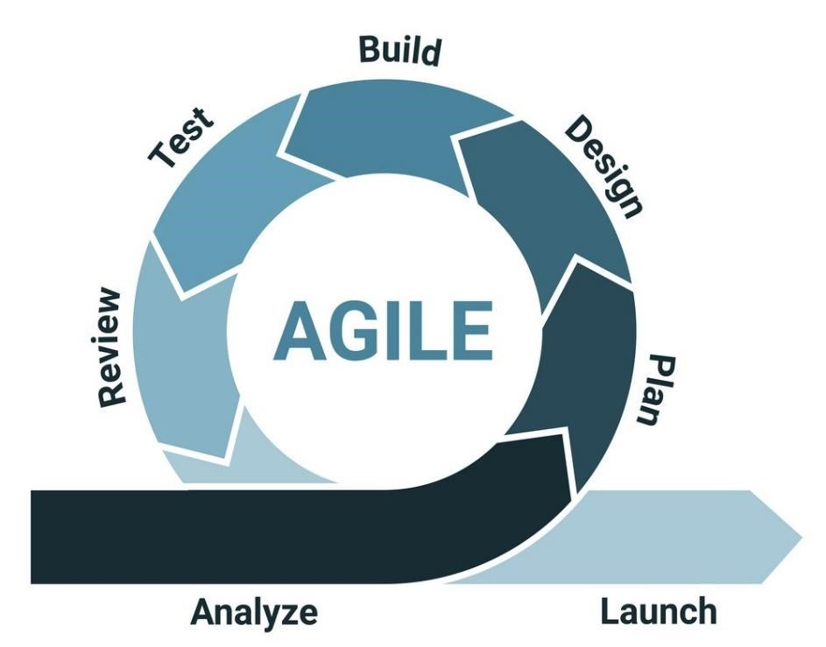

**Figure 1: Agile Software Development Life Cycle Diagram**

In Figure 1, specified here the process structured series of stages that a system goes through as it moves from beginning to end. We discussed each contains six phases: analyze, plan, design, build, test, review, and launch for how does the workflow that we will make system.

Analyze is the first stage of the Agile Software Development Life Cycle. In this stage, the researcher identified the system users and the needs and requirements to build in the system making. The researcher identified the necessary requirements for the project by data gathering from other related existing applications through researching and brainstorming. This is to have an idea to improve the system that they will use.

The following stage is planning. At this stage, the researchers decide which tools will be used, and created a timetable for how long the project will take. For the design and layout, the researcher used Bootstrap, PHP, AJAX, JavaScript, HTML, and SQL in the system making.

During the Design phase, the researchers created their own design of the project's interface and its functions. The researchers considered a design that would be easily understood and navigated by users. The researchers conducted an interview and consultation to adviser and co-adviser regarding to the proposed design of system that are making. The researchers also conducted a comparison of the system to the existing system in order to have an idea of the other design that can be use. The researcher used Bootstrap, JavaScript, and AJAX to implement the desired design of the system.

During the Build phase, the researcher will divide the work between coding, design, and documenting the necessary information. The researcher search for the specific tools required to develop the system. First, the researcher gathered the appropriate software and hardware requirements, such as laptops or personal desktop computers to use in the system's development process. PHP: Hypertext Preprocessor, which the researcher used to create dynamic and interactive HTML Web pages in conjunction with SQL in the process of developing the system, this is the software required to develop the said system. The researchers used the Visual Studio IDE or VsCode as the code editor, which the researchers used to create programs such as PHP, HTML, SQL, AJAX, Bootstrap, and JavaScript for the system's development.

In the Test phase, the researchers executed their first attempts to run the project, and document all errors that occur, and iterate back to the first phase to resolve any issues that arise.

The phase Review. At this stage, the assigned researcher in this phase check to see if any of the other researcher have forgotten to meet the software requirements or if there have been any changes to the design, features and important data.

Launch is the final stage. At this stage, the developers demonstrate the success of the initial part of the system development of applications to the users, as well as the final output of the documentation.

**Scrum Methodology in Agile Method**

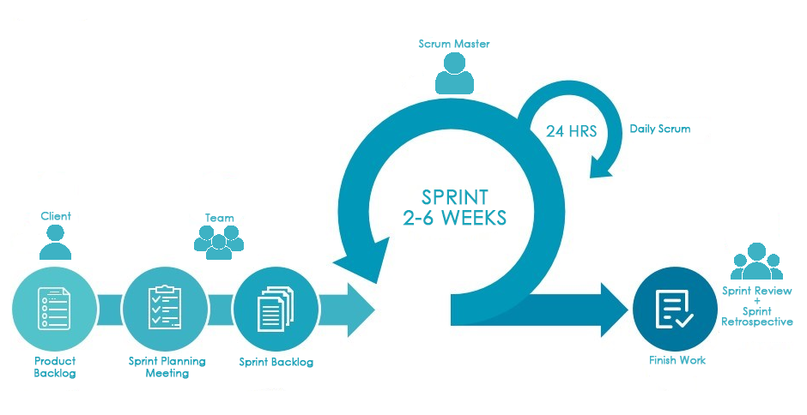

**Figure 2: Scrum Methodology Diagram**

The Figure 2 shows the process of the Scrum Methodology that the researcher used to manage tasks within this development project. The first phase in Scrum Methodology is between client and the product backlog. In product backlog, the researchers prioritized the list of work that must done for the development of the project together with the main features, user stories, use cases, bugs, technical work and knowledge acquisition of this project. This important list enumerated in the product backlog for the researchers to know what to deliver first. For the sprint planning, the researchers define the work to delivered in a series of time or sprint for them to know how the work will achieve. The main objectives of this phase is that the researcher knows and identify what the series of work are needed to be done in a series period of time. In the Sprint backlog, researchers identify the tasks of what functions included in the next increment and what work are required to deliver those functions to the selected list of product backlog items. The scrum master or the head facilitator held a meeting for conducting progress reports for the daily scrum, this progress report continues every 24 hours in 2-6 weeks on which it focuses on progress towards the sprint goal and produces an actionable plan for the next day of the task work. The finish work together with the sprint reviewee, researchers and client gathered for the discussion of the sprint results of the project. Lastly, the sprint retrospective, will held a meeting for the discussion on what went and how the cycle of sprint goes. The essential end part on which completes the development, deliberations of the researcher’s project.

**System Requirements**

The system's software and hardware requirements are shown in the table (number). The operating system must be Windows 7 or higher, the browser must be Google Chrome (open source), the hosting site must be 000 Webhost (free), the internet connection must be 5mbps or higher, the markup language must be html (free), the scripting language must be PHP, JavaScript, ajax (free), the database programming language must be SQL (free), and the framework must be bootstrap. In terms of hardware, the storage space must be 1TB HDD or 128gb SSD, the Memory (RAM) must be 4gb RAM, and the processor speed must be 1.8 GHz.

|  |  |  |
| --- | --- | --- |
| **ITEM NAME** | **SPECIFICATION** | **LICENSE** |
| Minimum free storage space | 1TB HDD or 128gb SSD | None |
| Minimum System Memory (RAM) | 4gb RAM | None |
| Minimum processor speed | 1.8 GHz | None |

**Software Requirements**

|  |  |  |
| --- | --- | --- |
| **ITEM NAME** | **SPECIFICATION** | **LICENSE** |
| Operating System | Windows 7 or above | License |
| Browser | Google Chrome | Open-source |
| Hosting Site | 000Webshost | Free |
| Internet Connection | 5mbps internet connection or above | None |
| Markup Language | HTML | Free |
| Scripting Language | PHP, JavaScript, Ajax | Free |
| Database Programming Language | SQL | Free |
| Framework | Bootstrap | Open-source |

**Hardware Requirements**

**Statistical Treatment of Data**

The researchers use this method thoroughly understand the relationship between variables which test a hypothesis by making conclusion from the collected data. This statistical method allow the researchers to investigate the statistical relationships between data and identify the possible errors in this study and if the study is to be reliable using the following tools below.

**5-Point Likert Scale**

The researchers used the 5-Point Liker Scale in the evaluation questionnaire in order to easily understand and use. The researchers used this Numeric Value Equivalent Rating 5 - Very Strongly Agree, 4 - Strongly Agree 3 - Agree 2 - Disagree 1 - Strongly Disagree in the evaluation questionnaire. This scale is used to produce a reliable data that can analyze with relative ease.

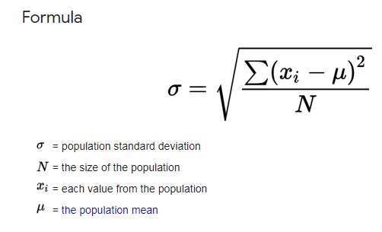**Arithmethic Weighted Mean**

**Figure 1. Arithmethic Weighted Mean**

The Figure 1 shows the method used to measure the central tendency of a set of quantitative observations when not the observation has the same importance. The researchers used it to calculate the average of the value of data collected.

**Evaluation Questionnaire**

The researcher conducted a questionnaire that will help to improve the design and functionalities of the system by getting the valuable feedback of the respondents. The results of the evaluation will also show if the goals and objectives off a program have been determined. The evaluation questionnaire that has been made are given below.

**Name (optional): Age:**

**Sex:**

Please rate the level by marking the column that corresponds to your evaluation with a check mark (✓). Numeric Value Equivalent Rating 5 - Very Strongly Agree 4 - Strongly Agree 3 - Agree 2 - Disagree 1 - Strongly Disagree. Use the scale below. How does the developed system comply with the ISO 25010 software quality standards in terms of the following factors?:

|  |  |  |  |  |  |  |
| --- | --- | --- | --- | --- | --- | --- |
|  | **QUESTIONS** | **5** | **4** | **3** | **2** | **1** |
| **1.** | **Functional Suitability** | | | | | |
| 1.1. | Completeness. The system is capable of completing all of the duties and achieving all of the user's goals. |  |  |  |  |  |
| 1.2. | Correctness. The system produces accurate results with the required precision. |  |  |  |  |  |
| 1.3. | Appropriateness. The system makes it easier to complete specified task and achieve goals. |  |  |  |  |  |
| **2.** | **Performance Efficiency** | | | | | |
| 2.1. | Time Behavior. The system's response and processing time meet the requirements, as well as throughput rates when doing its functions. |  |  |  |  |  |
| 2.2. | Resource Utilization. The quantity and types of resources used by the system to accomplish its operations are adequate. |  |  |  |  |  |
| 2.3. | Capacity. The system’s maximum limits of parameter meet requirements. |  |  |  |  |  |
| **3.** | **Compatibility** | | | | | |
| 3.1. | Co-existence. The system can carry out its functions effectively while sharing a common environment and resources with other products, without detrimental impact on any other product. |  |  |  |  |  |
| 3.2. | Interoperability. Information can be exchanged and used by the system. |  |  |  |  |  |
| **4.** | **Usability** | | | | | |
| 4.1. | Appropriateness Recognizability. The system helps users to determine whether it is suitable for their requirements. |  |  |  |  |  |
| 4.2. | Learnability. The system can be utilized by specific users to accomplish specific goals such as learning to use the application effectively, efficiently, without risk, and with satisfaction in a specific context of use. |  |  |  |  |  |
| 4.3. | Operability. The system contains features that make it simple to use and control. |  |  |  |  |  |
| 4.4. | User Error Protection. The system prevents the users making errors. |  |  |  |  |  |
| 4.5. | User Interaction Aesthetics. The user interface of the system allows for pleasant and fulfilling interaction. |  |  |  |  |  |
| 4.6. | Accessibility. The system can be utilized to attain a specific goal in a specific situation by people with a wide range of features and skills. |  |  |  |  |  |
| **5.** | **Reliability** | | | | | |
| 5.1. | Maturity. The system meets the needs for reliability during normal operation. |  |  |  |  |  |
| 5.2. | Availability. The system is accessible and operational and ready to use whenever it is needed. |  |  |  |  |  |
| 5.3. | Fault Tolerance. The system performs as expected despite the presence of hardware or software flaws. |  |  |  |  |  |
| 5.4. | Recoverability. The system can recover the data that has been directly harmed and restore the desired state. |  |  |  |  |  |
| **6.** | **Security** | | | | | |
| 6.1. | Confidentiality. The system only allows the authorized person to access the application. |  |  |  |  |  |
| 6.2. | Integrity. Unauthorized access to, or modification of, computer programs or data is prevented by the system. |  |  |  |  |  |
| 6.3. | Non-repudiation. The system can be demonstrated to have occurred, ensuring that the events or actions are irreversible. |  |  |  |  |  |

**Subject of the Study**

The researchers included participants who are needed in the development of the study. The participants in this study were composed of some of the CCIT Faculty members.

## **Data Gathering Instruments**

The Researchers used the following data gathering instruments in order to gather relevant data for the development of Collaborative software application. The instruments used are techniques which consist of interview and topic research.

**Consultation.** The researchers conducted a consultation of the development system to Doctor Raymund Baesa (CCIT Professor), and Doctor Maricel Malabanan-Gaspar (BSIT Chair). The consultation was conducted to know the problem regarding their usage of collaborative tool in CCIT Department. This is to gather their opinion and suggestions to improve the collaborative software application.

**Brainstorming.** The researchers shared their conclusion about the specific problem and suggested an idea on how to improve the development of the collaborative software tool.

**Research.** The researchers conducted a gathering of data in order to have an idea basis, to know the comparison of existing collaborative tools, and to study the materials and resources that are needed and included in the development of the collaborative application.

## **Data Gathering Procedure**

The researchers conducted a consultation of system in a form of virtual interview to some CCIT Faculty members. The researchers came up with the information needed in development of Work On: A Collaborative Web-Based Application for Employee’s Work Progress of CCIT Faculty as an approach to track and monitor the works of the faculty.

The researchers used the “Use Case Diagram” as an approach to describe the high-level functions and scope of the project. The diagram also shows the interaction between the proposed application project and the users. This methodology illustrates and define the context and requirements of the application.

In this context, a “Work On: A Collaborative Web-Based Application for Employee’s Work Progress” of CCIT Faculty will be implemented.

**Unified Modeling Language (UML) Diagrams**

The use of UML is to develop diagrams and provide users with ready-to-use modeling samples. In the UML, the researchers included the Use Case Diagrams of the administrator, users and project manager. This UML also shows the DFD level 0 and level 1 diagrams of the system. The database schema is also given in the UML. The said diagrams are given below.

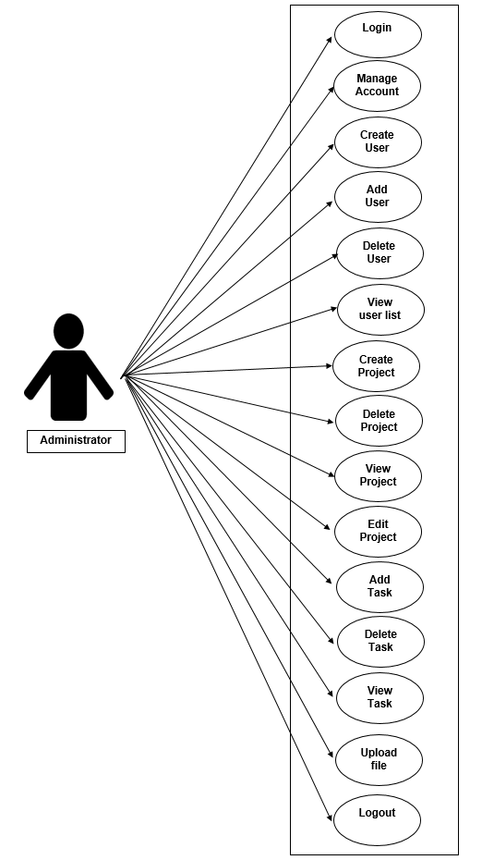

**Figure 1.1 Work On: A Collaborative Web-Based Application for Employee’s Work Progress Use Case for Administrator**

Figure 1.1 shows the Use case diagram for Administrator. The administrator can login, manage accounts, create, add, and delete users, view the user list, create, delete, view, and edit projects, add, delete, and view tasks, upload files, and logout.

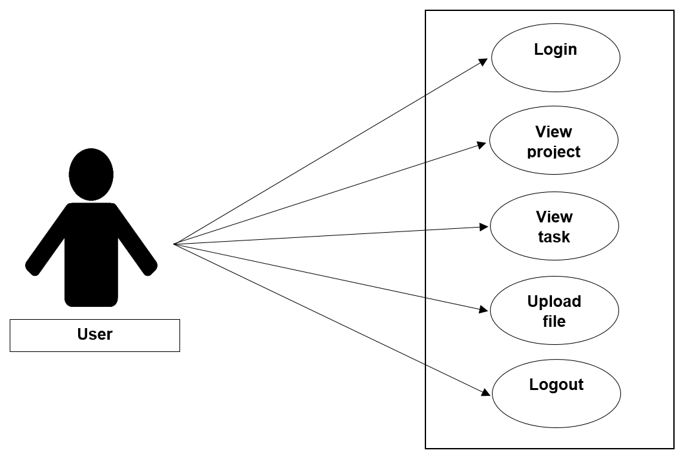

**Figure 1.2. Work On: A Collaborative Web-Based Application for Employee’s Work Progress Use Case for Project Manager**

Figure 1.2 shows the Use case diagram for Project Manager. The project manager can login, manage accounts, delete, view, and edit projects, add, delete, update and view tasks, upload files, and logout.

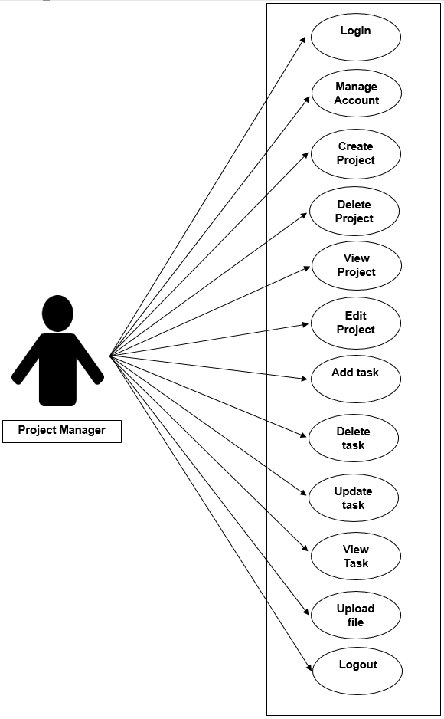

**Figure 1.3. Work On: A Collaborative Web-Based Application for Employee’s Work Progress Use Case for User**

Figure 1.3 shows the Use case diagram for User. The user can login, view project, view task, upload file and logout.

**Data Flow Diagram**

**DFD Level 0**

The Figure 1.4 shows the process of the system that the Admin will create user to manage creating project then the Project manager will update the project and assign task to the User then the User will update the task to have a project information that will receive by the Admin.

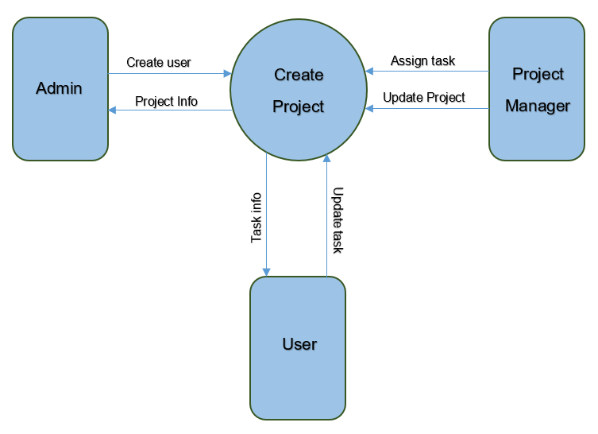

**Figure 1.4 Work On: A Collaborative Web-Based Application for Employee’s Work Progress DFD Level 0 Diagram**

**DFD Level 1**

The Figure 1.5 shows how the Administration, Project Manager and Users flow of works along with the system. It shows how well they communicate to process the input data and output data. The admin is capable to delete, edit, view and create a project. Also admin can delete, update task and upload file. The project manager is capable on view, assign, delete, and update task and project that will be installed to project storage file. Project manager can create project that will be forwarded to become a project information then this will be the given that will be forwarded to the users only. For the user part, they are able to view, update task and upload file. All data that will be forwarded will be processed to project information and will store in project storage file. The data that are input in the project information will go back to the Project Manager and Admin in order to get the stored information back to them.

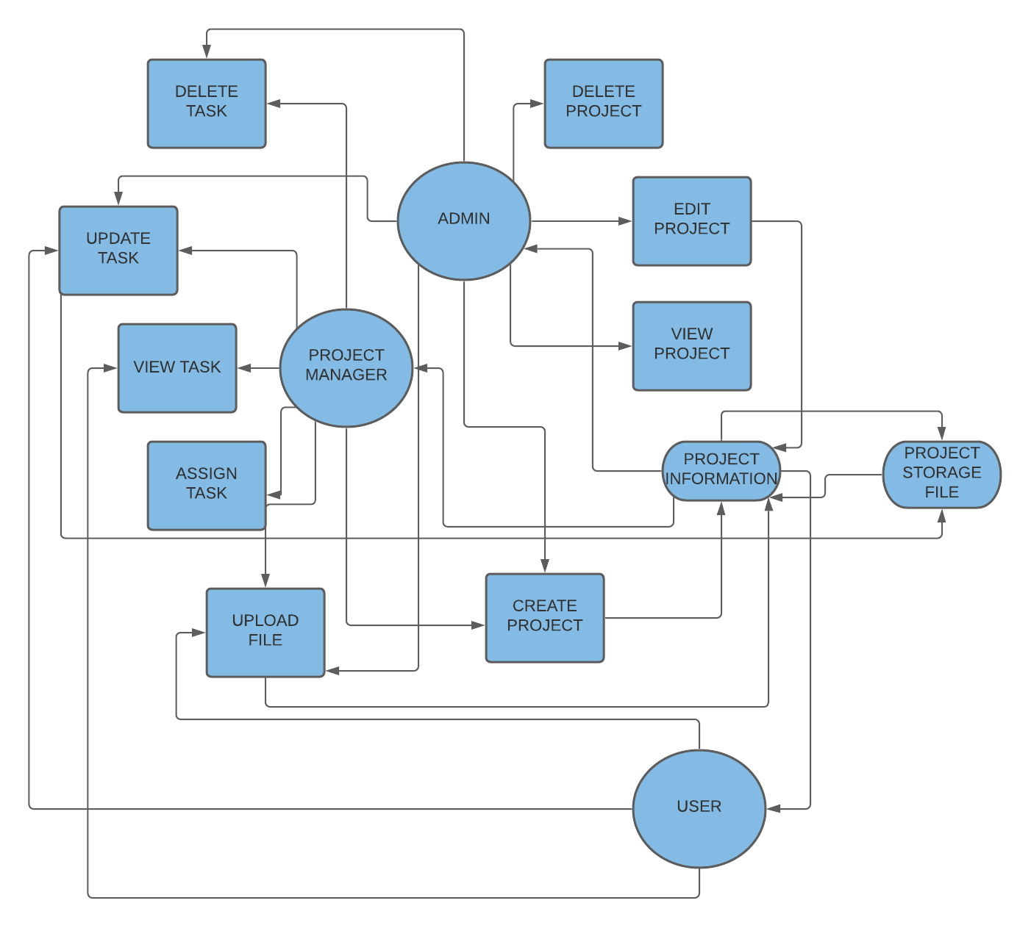

**Figure 1.5 Work On: A Collaborative Web-Based Application for Employee’s Work Progress DFD Level 1 Diagram**

**Database Schema**

The figure 1.6 shows the flow and relationship of the data, and this Database Schema represents the blueprints of the system to visualize the building of the system. This database schema is partially design to fulfill the implementation of the system. The database has a six groups which are the task list, user productivity, project list, users, system setting and group list. The ID in the task list group is the primary key and the task id that are in user productivity is the foreign key. The project list id is the primary key that connects to the project id which is the foreign key in both task list, group list, and user productivity. The id in users group is the primary key and the foreign keys of it are the user id, and task id. The system setting id is the primary key and it is connected to manager id and member id as the foreign keys.

**Figure 1.6. Work On: A Collaborative Web-Based Application for Employee’s Work Progress Database Schema**

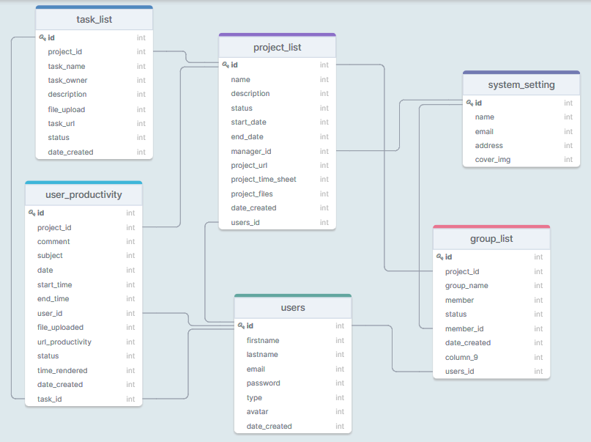

**Chapter IV**

**PRESENTATION, ANALYSIS AND INTERPRETATION DATA**

This chapter presents the data gathered, the result of analysis and interpretation of data concerning the present study.

**1. Web- Based Application Development are capable of**

1.1 Creating an account for Administrator, Project Manager and User.

1.2 Administrator can login, manage account, create add and delete users. View the user lists, create, delete, view and edit projects. Add, delete and view tasks then upload files.

1.3 Project Manager can login, manage account, delete, view and edit projects. Add, delete, update and view tasks then upload files.

1.4 Users can login, view project, view task and upload file.

1.5 Document time sheet through URL.

1.6 Printing report and uploading documentation through URL.

1.7 Syncing of import data.

**2. Status and progress of assigned tasks or projects generated.**

2.1 Generates report for completed, incomplete, and ongoing task or project of the project manager and the user.

2.2 Administrator and Project Manager can print daily or weekly reports.

**3. Showing attendance through URL.**

3.1 Generates timesheet using URL link.

3.2 Generates file upload for submission through URL link.

**LOGIN PAGE**

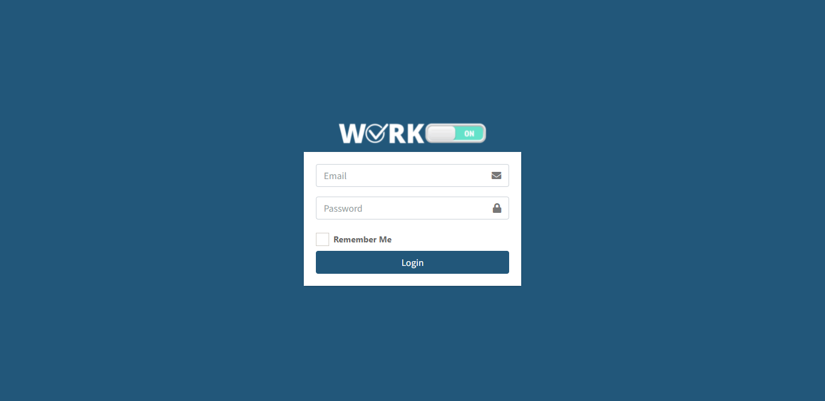

The Admin, Task Manager, and User will login into this Web-Based App first before creating a task or assigned task. In order to have an account, the Admin will create user for Task Manager/Leader then the Task Manager/Leader can also create the account for user.

**FOR ADMIN**

**DASHBOARD PAGE**

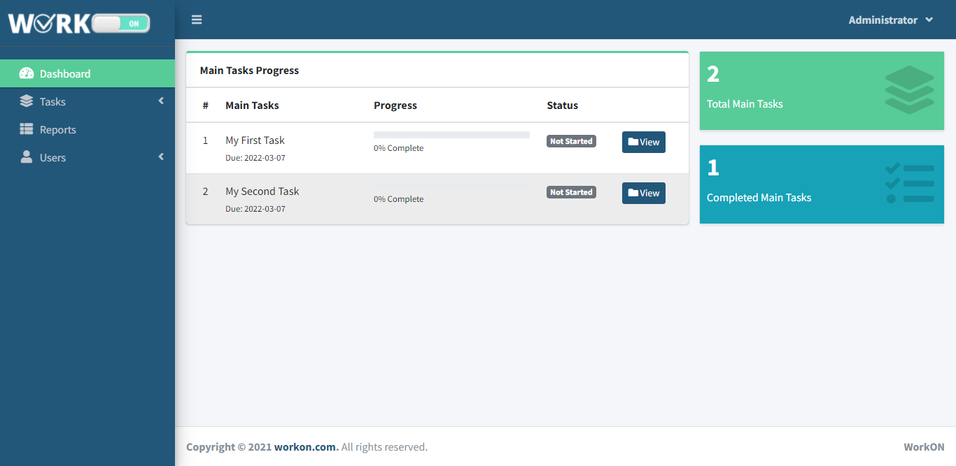

The Dashboard will show the Main task progress board that has a created task name that can view. It also shows the total of main task and total of completed main task.

**ADD NEW USER PAGE**

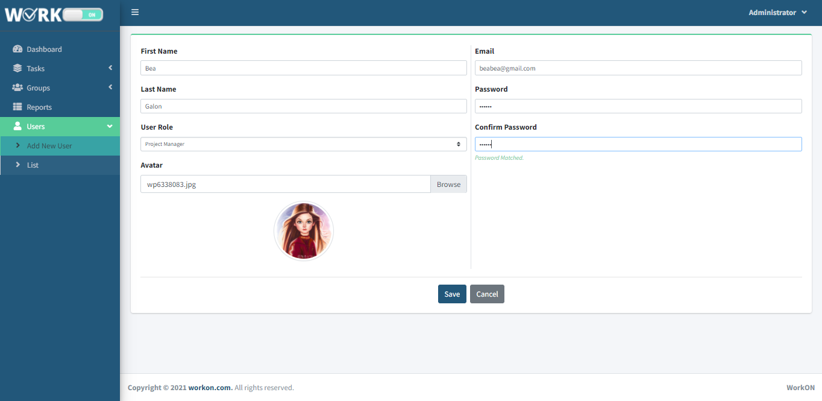

The Task Manager and Admin can create user that will use the Work-On Web-Based App. This create new user page has need to fill up the First name, Last name, User role, Avatar for icon but it’s optional, E-mail, Password and confirm password.

**USER LIST PAGE**

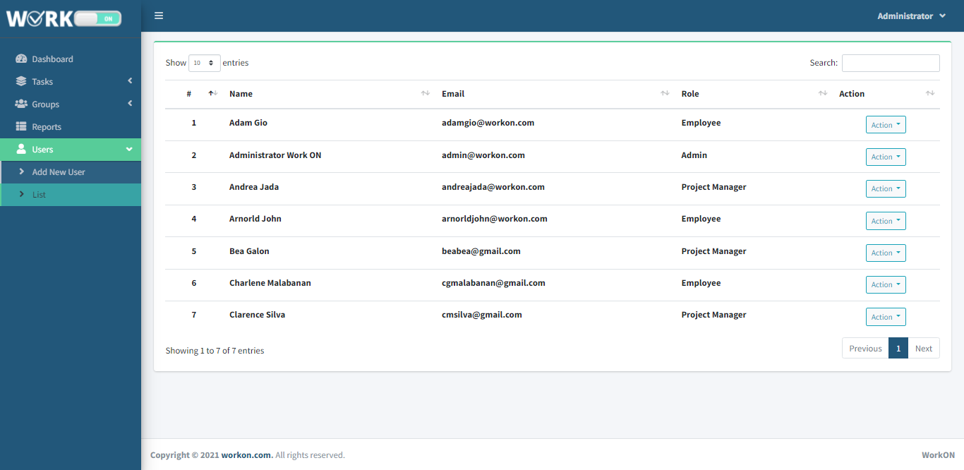

In the user list page, the Task Manager and Admin can see all the users that has been created. They can view it in action button. The action button has edit, view and delete.

**CREATE TASK PAGE**

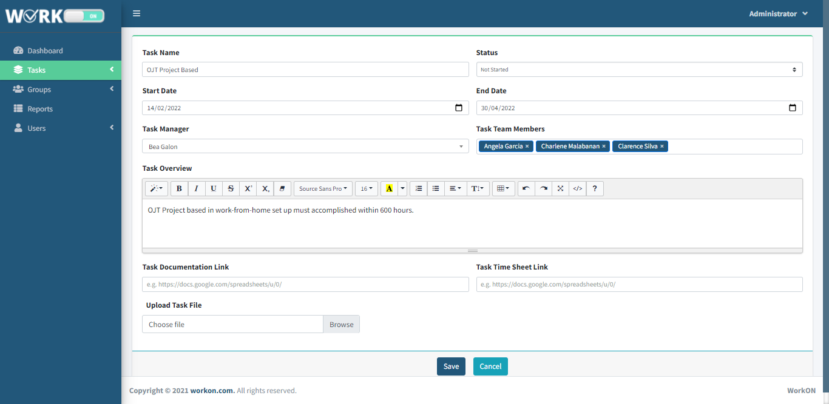

The Task Manager and Admin can create task. In creating the task, the task manager and admin will fill up the Task Name, Start Date and End Date for the start and end of work, the Status is for the progress of task, the Task Manager and Task Team Members for the identification of who are included in the task.

**TASK LIST PAGE**

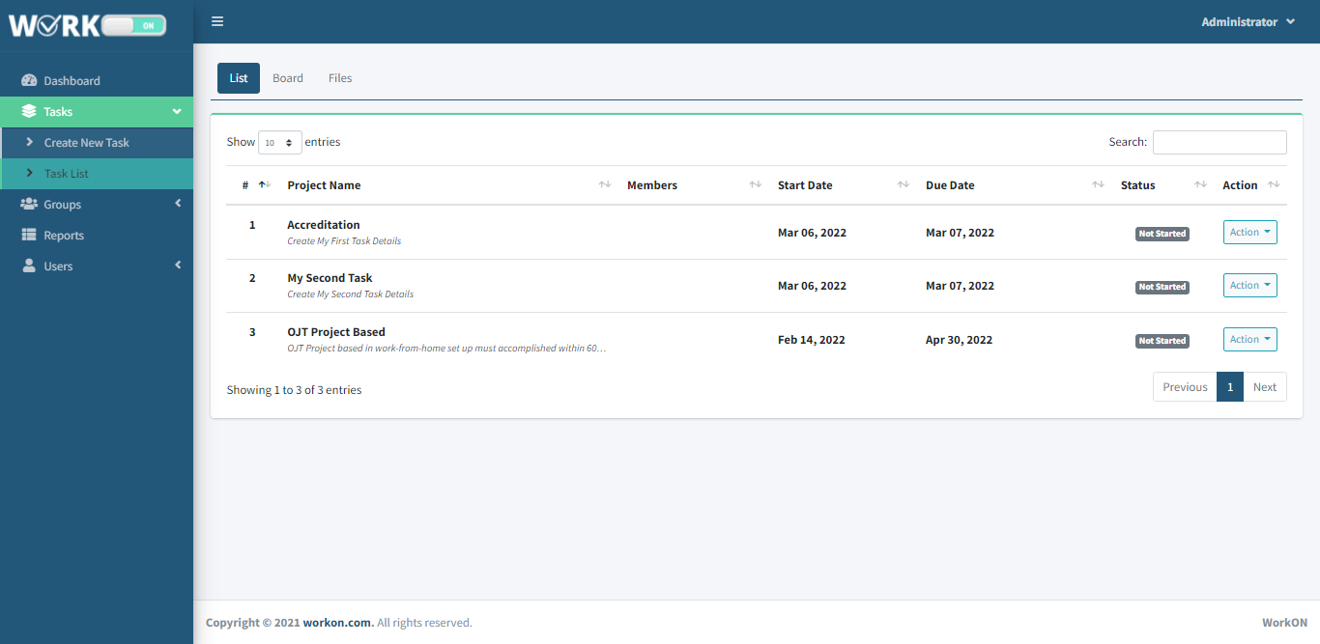

In the Task List page, you will see all the created task. The task displays the members, start and end of date, status and action. In action it can be view, edit and delete.

**CREATED TASK PAGE**

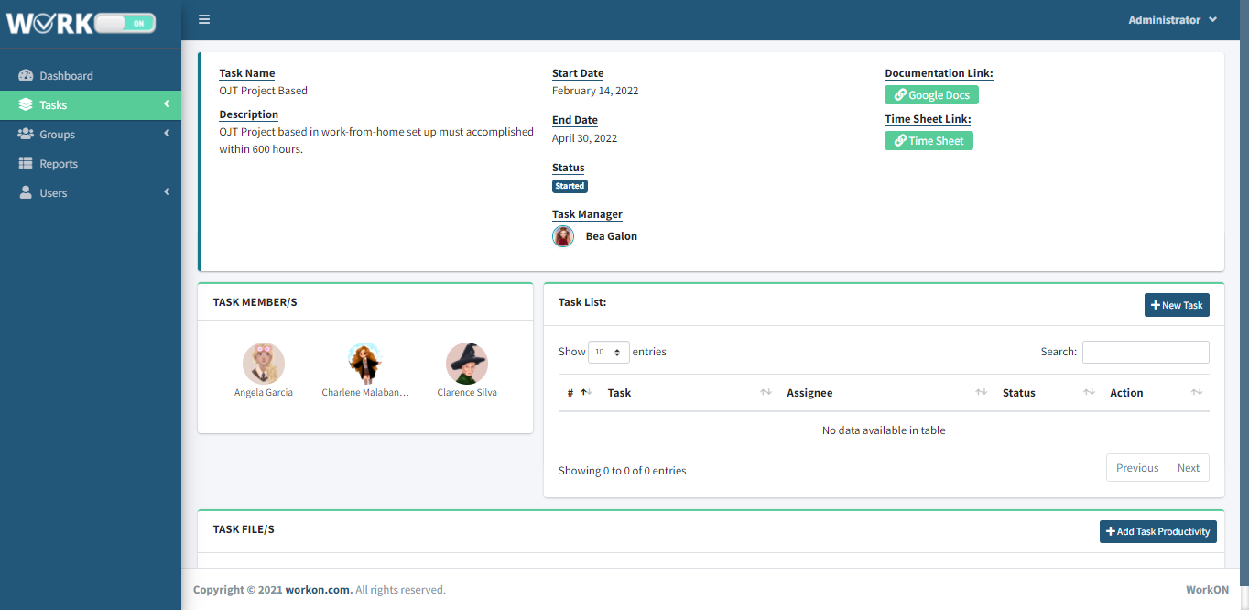

In created task page, it will show the Task Name, Start Date and End Date for the start and end of work, the Status for the progress of task, the Task Manager and Task Team Members for the identification of who are included in the task.

**ADD ASSIGNED TASK**

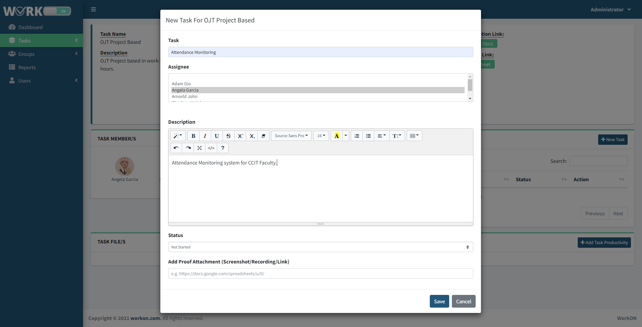

The Task Manager will upload the assigned task and give it to the assignee and it can attach it with a sample document or extension link.

**EDIT ASSIGNED TASK**

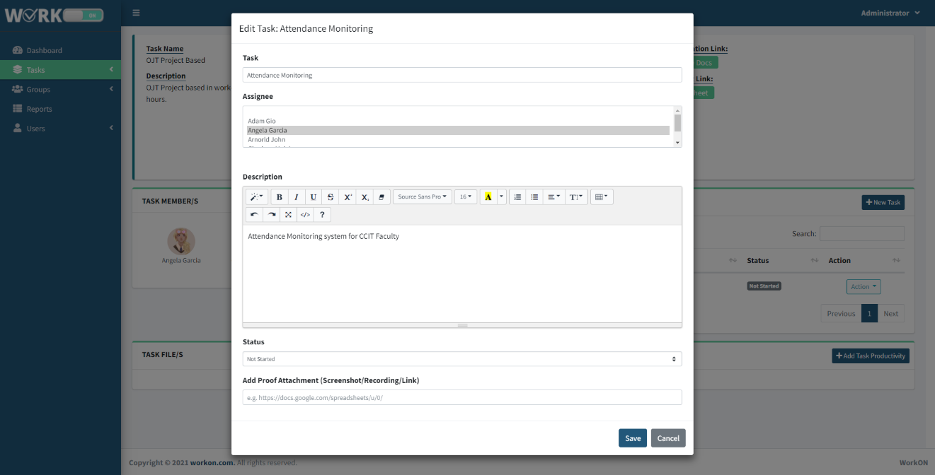

The assigned task can update for the needed changes.

**DELETE ASSIGNED TASK**

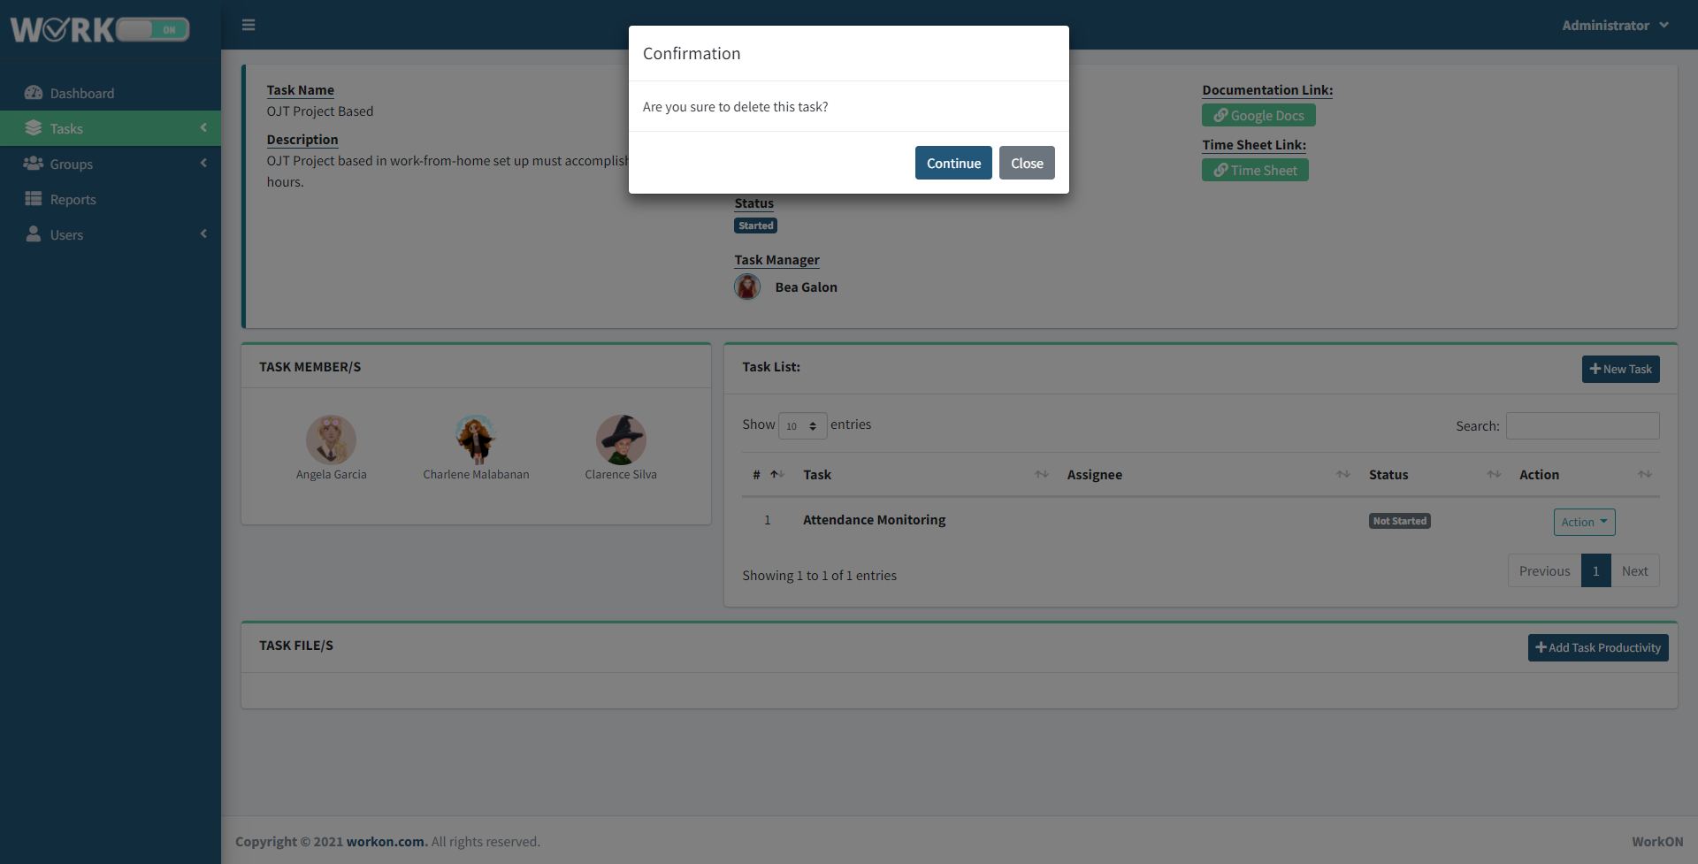

The assigned task can be deleted and will show up a confirmation notification before it will delete permanently.

**FOR PROJECT MANAGER**

**DASHBOARD**

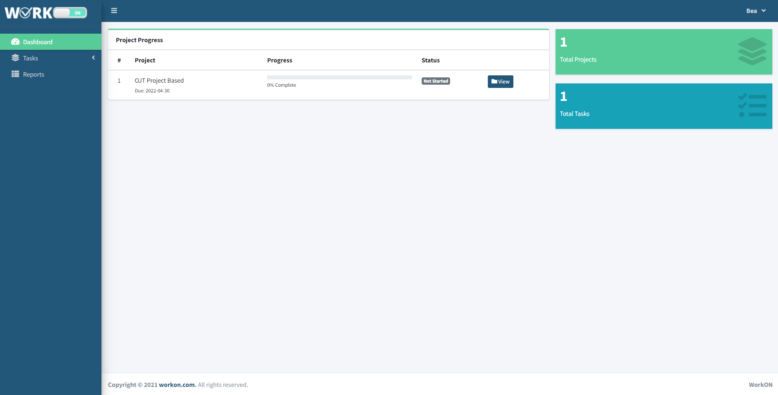

The Dashboard will show the Main task progress board that has a created task name that can be view. It also shows the total of main task and total of completed main task. It is the same dashboard of the Admin.

**TASK LIST PAGE**

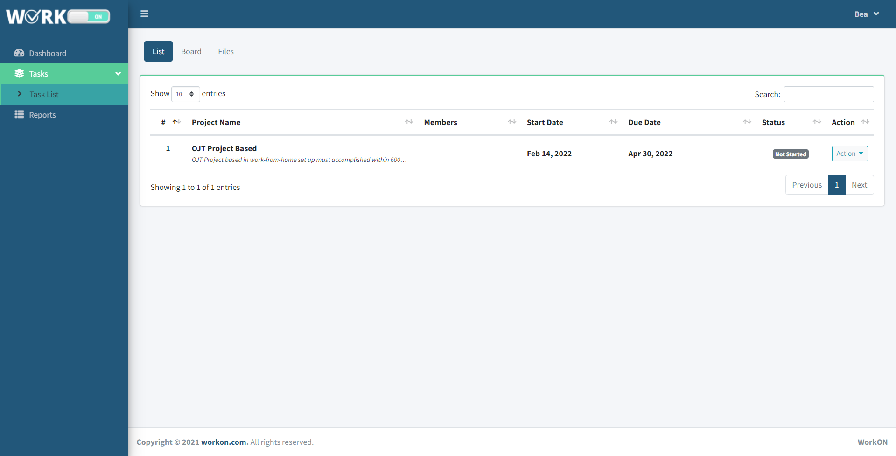

In the Task List page, you will see all the created task. The task displays the members, start and end of date, status and action. In action it can be view, edit and delete

**BOARD PAGE**

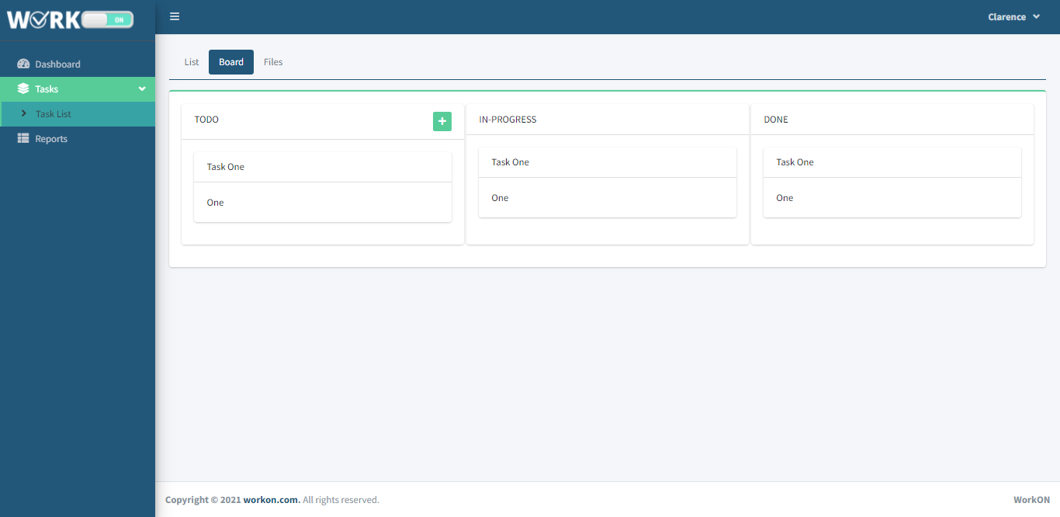

This board page is where the Admin or Project Manager will monitor and view the status of overall task. It has a To-Do, In-Progress and Done panel box.

**SUBMITTED FILES PAGE**

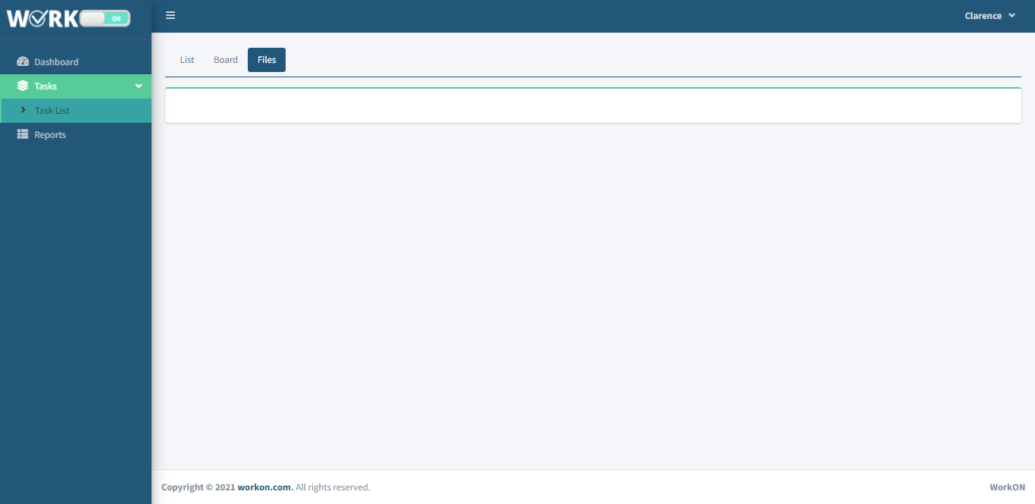

The submitted files page will show all the compiled files that are uploaded in the upload task file page.

**FOR END USER/EMPLOYEE**

**DASHBOARD**

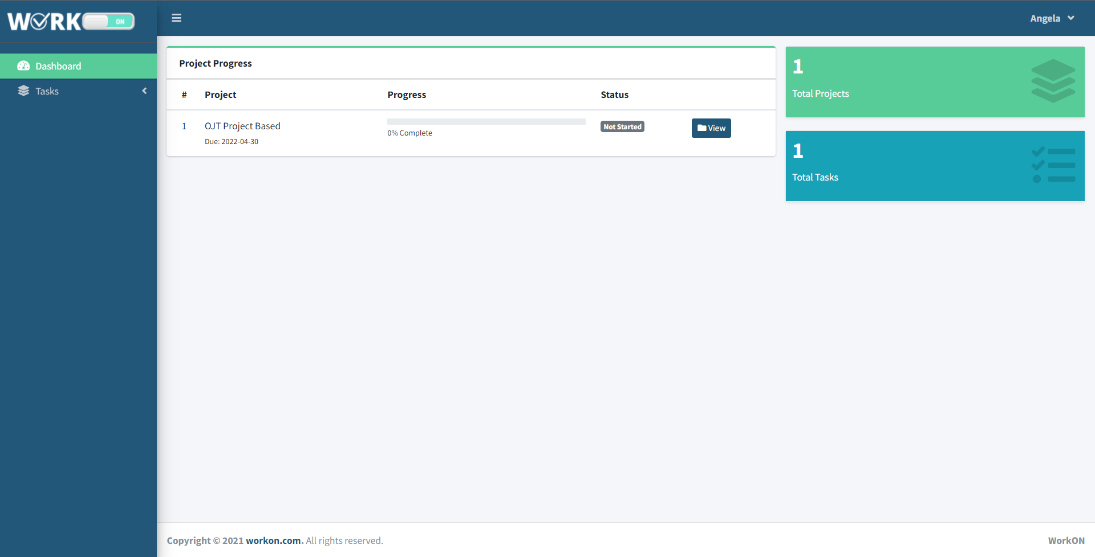

The Dashboard will show the Main task on which it only has the assigned task of the current employee. It also shows the total of main task and total of completed main task.

**ASSIGNED TASK VIEW**

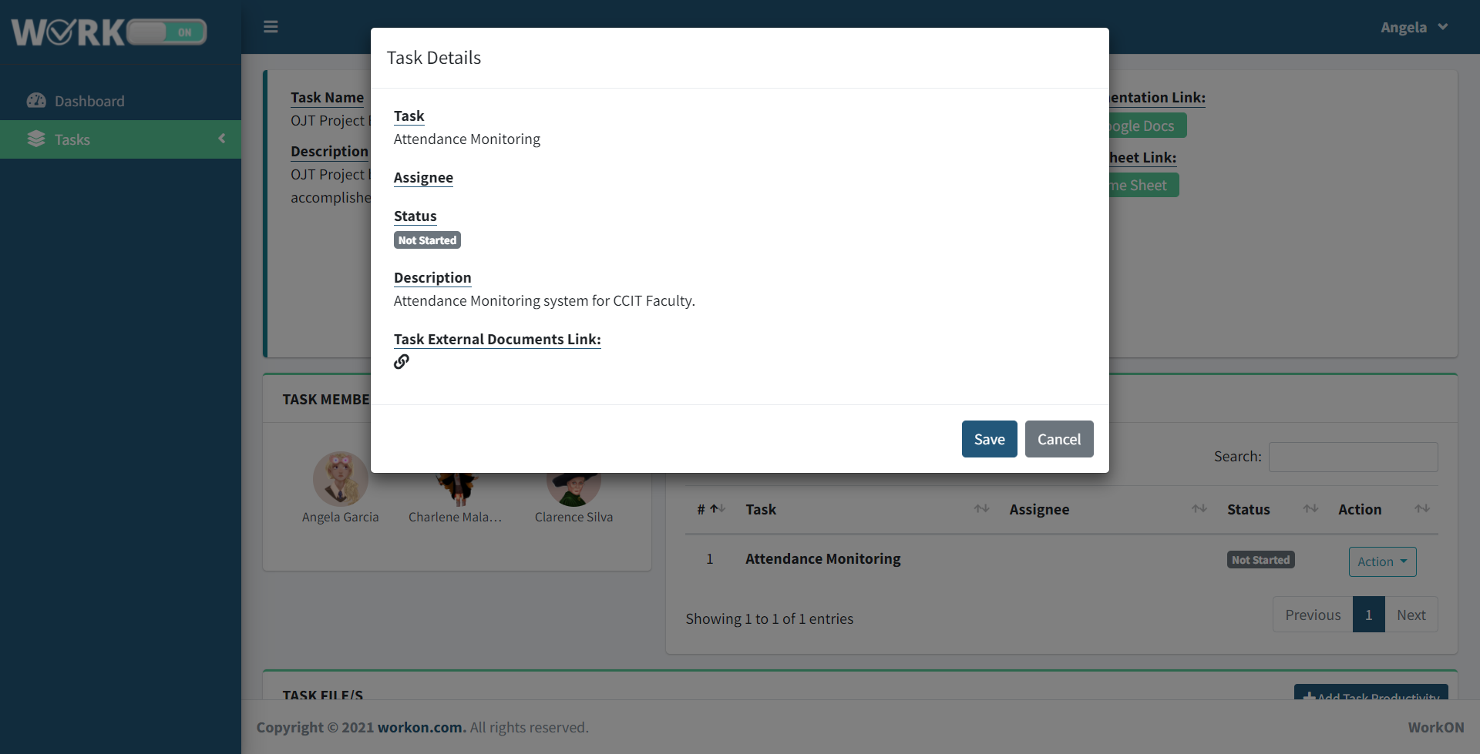

The employee will only view the task assigned to her. The task details show the Task title, Assignee name, Status, Description and the Task link on which it can be a URL that will guide the employee by doing the task.

**FOR ADMIN, PROJECT MANAGER, AND END USER**

**UPLOAD FILE/TASK PROGRESS**

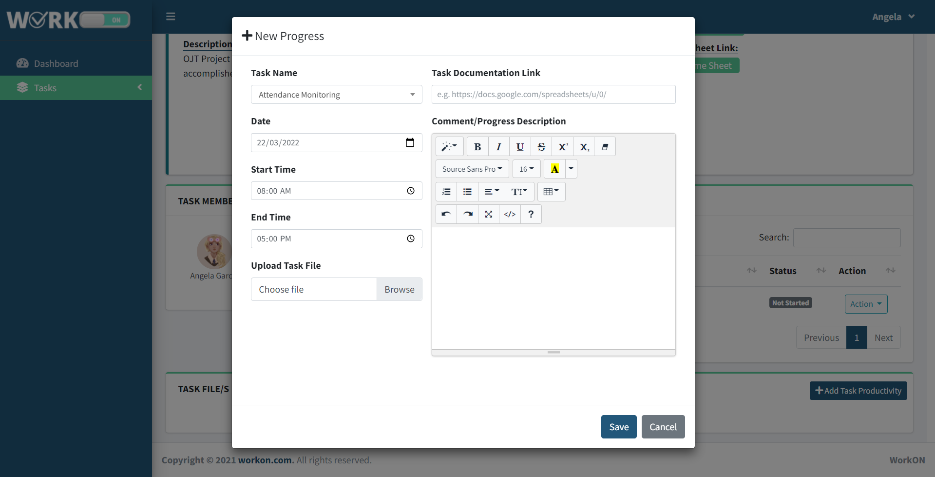

The New Progress button will put you in the page where you will fill up the Main Task name, date of when you submitted it, start and end time of your work, project documentation link for the extension of progress and comment progress description. The employee can upload the progress file.

**TASK FILE UPLOADED**

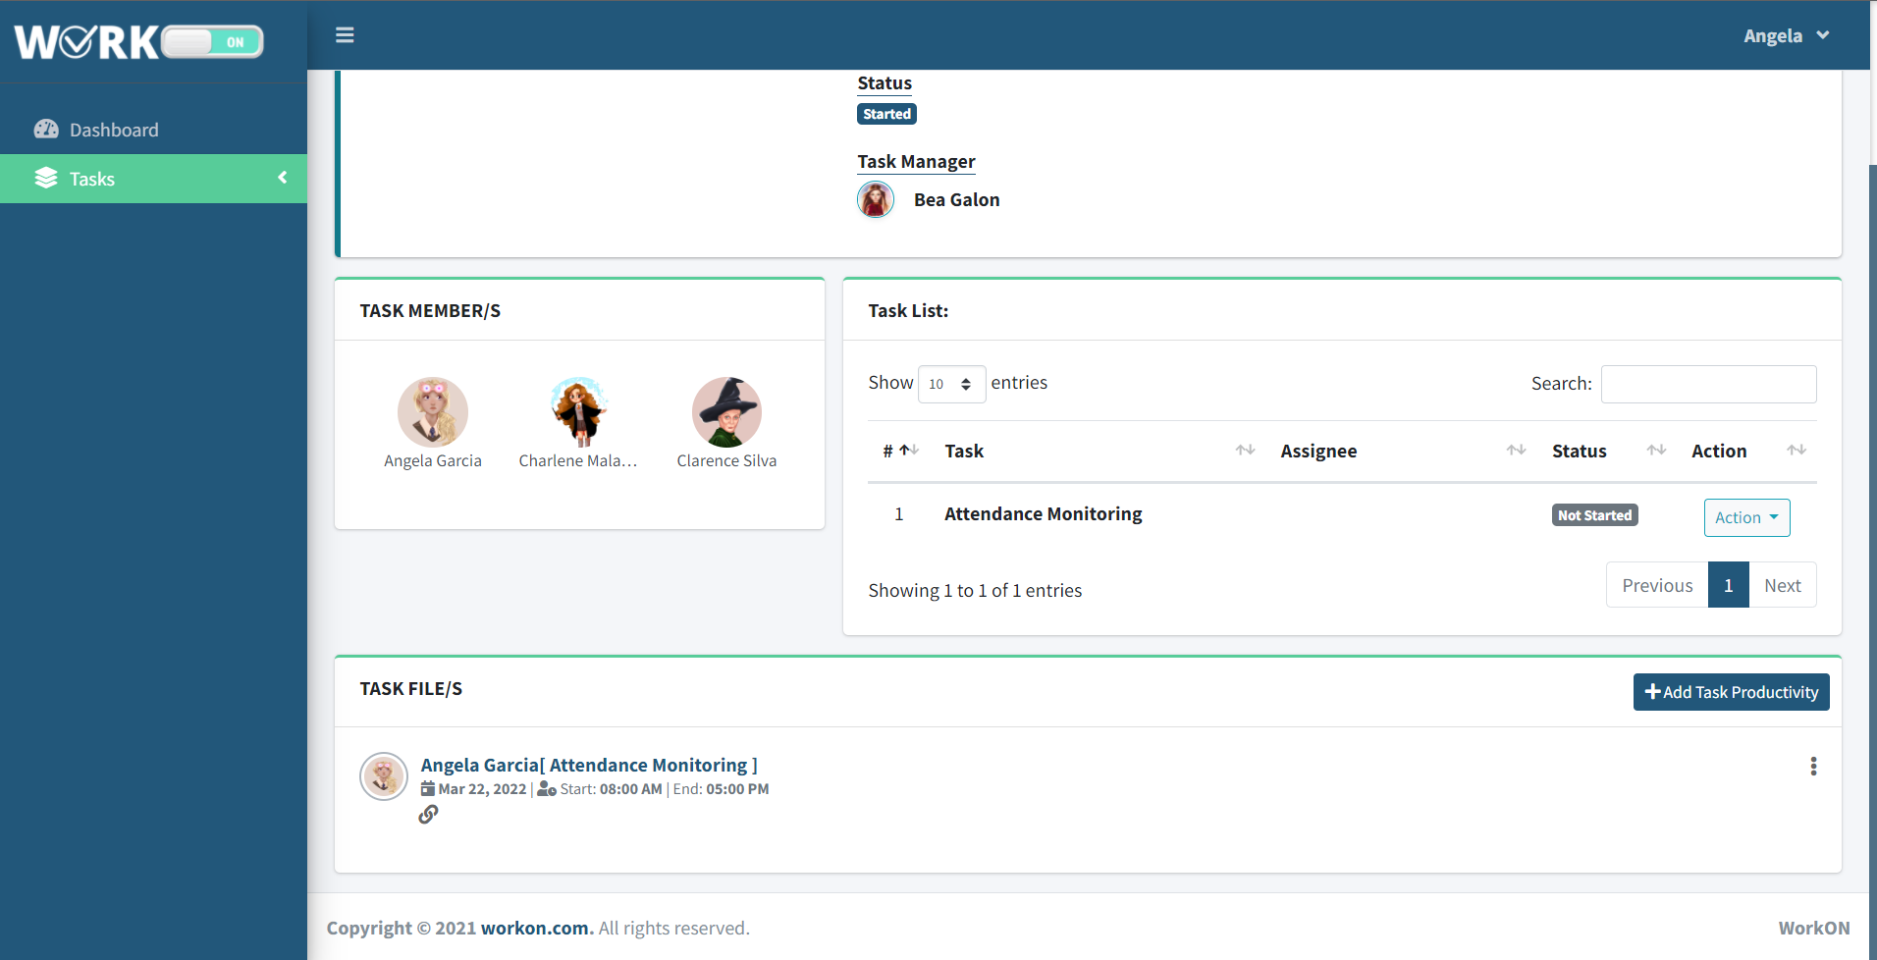

The submitted file of the assignee will show in the bottom part of the Task Page.

**SUMMARY OF REPORTS**

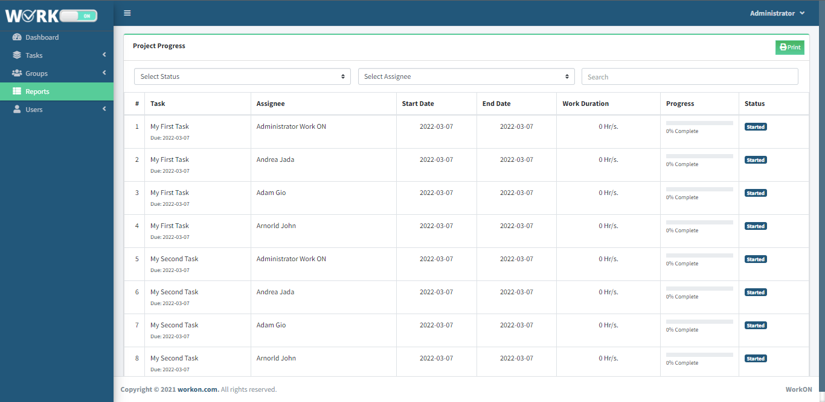

All the created task will compile in this page. The Admin and Task Manager can view all the created task and can view the status of all the task progress.

**PRINT REPORT**

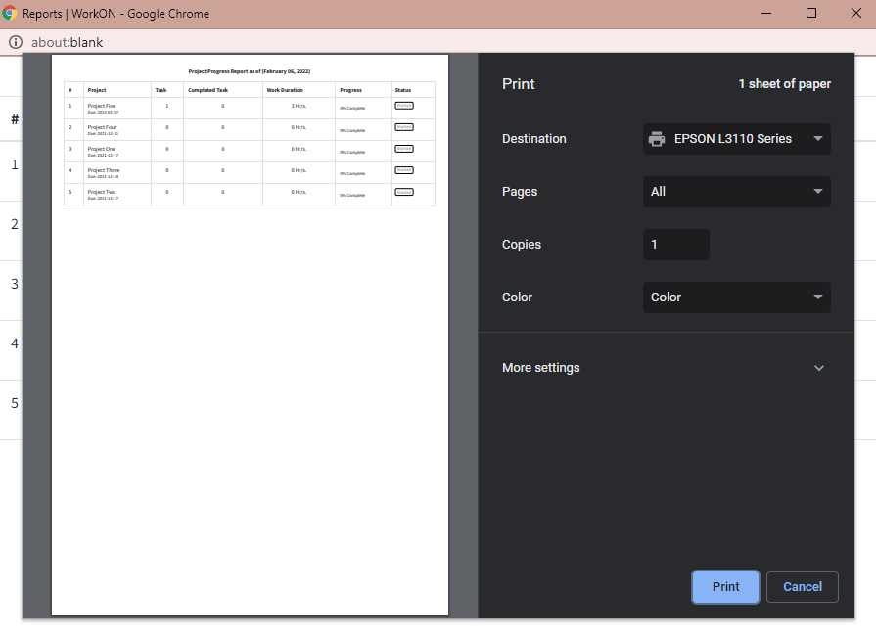

The summary report of the task can be print by Admin and Task Manager.

**MANAGE ACCOUNT**

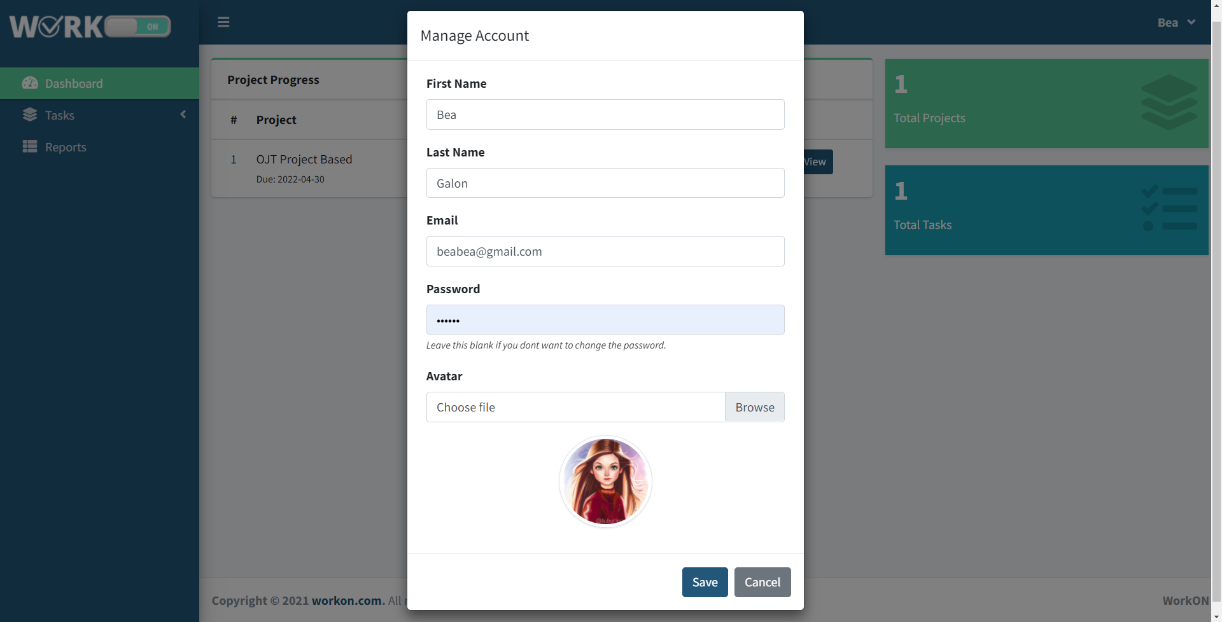

The Admin, Task Manager, User can manage their account by editing their personal information.

**Chapter V**

**SUMMARY, CONCLUSION AND RECOMMENDATION**

This chapter summarizes the findings, conclusions, and recommendations based on the study's findings.

**Summary**

The researchers' main goal is to create and design a Web-based application that will allow the project manager to track and monitor the progress of the employees' work. The study specifically seeks to:

1. To create and develop a system that capable of

1.1 Providing a task where the Project Manager or Admin can assign and give a task to their project members or employees.

1.2 Providing a task where the Project Manager or Admin monitor their Project Members working on their given task.

1.3 Providing a task and project that can update and edit the project task in real time.

1. To provide a software that has a data sync for the submitted files, and notes for the important announcement.

**Conclusion**

The following conclusions were reached based on the study's findings:

1. The system can be seen as a valuable tool for the project manager in tracking and monitoring the employee's work progress.
2. The study, scientific trials, and methodology used to develop the framework were all deemed successful.
3. The developed system enables employees to increase productivity by improving their ability to estimate the time required to complete tasks and projects.
4. The developed systems are a solution to the work problems that may arise when working in a group, such as miscommunication, difficulty managing the employee's task progress, employee lack of productivity, and difficulty identifying the work problem.

**Recommendations**

Based on the conclusions of this study, the following recommendations stated:

1. That the College of Computing and Information Technology may utilize the system.
2. It is recommended for future researchers to use the study as reference.

**REFERENCES:**

Etuk, E. (2016). *An Android based Employee Tracking System.* ResearchGate.

<https://www.researchgate.net/publication/310761520_An_Android_based_Employee_Tracking_System>

Finnegan, M. (2020). *The New Normal: When work-from-home means the boss*

*is watching.* ComputerWorld. <https://www.computerworld.com/article/3586616/the-new-normal-when-work-from-home-means-the-boss-is-watching.html>

Ravid, D. & Tomczak, D. & White, J & Behrend, T. (2019).

*EPM 20/20: A Review, Framework, and Research Agenda for Electronic Performance Monitoring.* Sage Journals. <https://journals.sagepub.com/doi/full/10.1177/0149206319869435>

Madhikar, G. & Mhaisne, N. & Patil, N. & Metkar, A. (2021). *A*

*Survey on Employee Tracking and Monitoring System using Android.* International Research Journal of Engineering and Technology (IRJET). <https://www.irjet.net/archives/V8/i6/IRJET-V8I637.pdf>

Kehinde, O. & Okafor, E. (2019). *The use of electronic monitoring*

*and work performance of employees in the banking industry in Ibadan, Southwest Nigeria.* Academic Journals. <https://academicjournals.org/journal/AJBM/article-full-text-pdf/36882F061027>

Çilgin, C & Tecim, V. (2018). *Designing Online Collaboration Tool*

*for Managing Postgraduate Education with New Web Technologies.* KnE Publishing. <https://knepublishing.com/index.php/Kne-Social/article/view/3544/7434>

Andersson, H. & Mutlu, A. (2020). *Digital collaboration tools, what*

*types of frustrations do managers experience?*. Lund University. <https://lup.lub.lu.se/luur/download?func=downloadFile&recordOId=9017193&fileOId=9017201>

Ravid, D., Tomczak D., White, J., & Behrend, T. (2019) *EPM 20/20: A Review,*

*Framework, and Research Agenda for Electronic Performance Monitorin.* ResearchGate.[*https://www.researchgate.net/publication/335279759_EPM_2020_A_Review_Framework_and_Research_Agenda_for_Electronic_Performance_Monitoring*](https://www.researchgate.net/publication/335279759_EPM_2020_A_Review_Framework_and_Research_Agenda_for_Electronic_Performance_Monitoring)

*Employee Monitoring: Pros, Cons, Types, Tools (2021 Guide)*. (2021). Time Doctor. <https://biz30.timedoctor.com/types-of-employee-monitoring/#comments>

**APPENDIX A**

**Cost and Benefit Analysis**

**Cost and Benefit Analysis**

Cost and benefits analysis is procedure for estimating all costs involved and possible profits to be derived from a business opportunity or proposal. It is the total cost of the development of the study.

Material Cost

|  |  |
| --- | --- |
| ITEM | PRICE |
| Soft Bind |  |
| Hard Bound |  |
| TOTAL |  |

Software Cost

|  |  |
| --- | --- |
| ITEM | PRICE |
| Web Host |  |
| TOTAL |  |

**APPENDIX B**

**Certificate of Grammarian**

**APPENDIX C**

**Curriculum Vitae**